*Aesthetic Fundamentals
5 C.E. Hours $380

*Skin Conditions
5 C.E. Hours $380

Understanding Galvanic Current Techniques
5 C.E. Hours $380

*Deep Cleansing Techniques (Desincrustation)
5 C.E. Hours $380

Deep Penetrating Techniques (Iontophoresis)
5 C.E. Hours $380

*Understanding High Frequency Techniques
5 C.E. Hours $380

Acne Specialist
5 C.E. Hours $450 with HF kit

Detoxifying & Purifying Techniques for the Skin
5 C.E Hours $380

Understanding & Treating the Fitzpatrick Scale
5 C.E. Hours $380

Treating Hyperpigmentation
5 C.E. Hours $380

Treating Aging Skin
5 C.E. Hours $380

Microchanneling
5 C.E. Hours $450

Microdermabrasion Techniques
5 C.E. Hours $380

Advanced Chemical Peeling Methods
5 C.E. Hours $380 or $720 with QT Kit

Dermaplaning
5 C.E. Hours $480 with kit

Microcurrent Techniques for the Face
5 C.E Hours $380

Hydra-Infusion Facial Techniques
5 C.E. Hours $380

Estheticians, Cosmetologists & *Barbers

*Treating Folliculitis
5 C.E. Hours $380

Facial Massage Techniques
5 C.E. Hours $380

Accelerated Body Waxing
5 C.E. Hours $380

Intimate Body Waxing
5 C.E. Hours $380 with kit

Full Body Relaxation Massage
5 C.E. Hours $380 with kit

Hot Stone Massage
5 C.E. Hours $450 with kit

Hot & Cold Stone Body Treatment
5 C.E. Hours $450 with kit

Microcurrent Gloves Massage
5 C.E. Hours $380 or $680 with kit

Body Vacuum Cupping Techniques
5 C.E. Hours $380

Tight &Toning Body Treatment Techniques
5 C.E. Hours $380

Anti-Cellulite Treatments
5 C.E. Hours $480 with kit

Cosmetic Ingredient Knowledge
5 C.E. Hours $380

Lash Enhancement & Brow Lamination
5 C.E. Hours $450 with kit

Spa Manicuring & Pedicuring
5 C.E. Hours $380

Nail Enhancement Techniques
5 C.E. Hours $380

Business Bootcamp
5 C.E. Hours $380

Instructor CE Training
8 C.E. Hours $380

Educator Training
5 C.E. Hours $380

Ohio Required Sanitation Class
3 C.E. Hour Class $90

State Board Required Wellness Class
1 C.E. Hour $50

Courses
Cosmetician
10-Week Course $5,495 with kit

Permanent Makeup
5-Day Course $2,800 with kit

Advanced Permanent Makeup
1-Day Course $800 with kit

Microblading
2-Day Course $2,200 with kit

Advanced Microblading
1-Day Course $1,000 with kit

*Advanced Peeling Techniques
14 C.E. Hours 2-Day Course $1,200

Eyelash Specialist
14 C.E. Hours 2-Day Course $1,200 with kit

Holistic Aesthetic Techniques
14 Hours 2-Day Class $700

Holistic Approaches through Aesthetics to Cancer Care Precautions
14 Hours 2-Day Class $700

We are a licensed permanent cosmetics & microblading facility. We also offer apprenticeship hours for counties that have this requirement.

All C.E. classes include the required 3 hours of required state board sanitation& 1 hour of wellness in the price. Required classes are offered monthly.

Aesthetic Fundamentals
$380

Skin Conditions
$380

Ventosis Techniques for the Face
$380

Galvanic Current Techniques
$380

Deep Cleansing Techniques (Desincrustation)
$380

Deep Penetrating Techniques (Iontophoresis)
$380

Understanding High Frequency Techniques
$380

Acne Specialist
$380 or $450 with HF kit

Detoxifying & Purifying Lymphatic Techniques
$380

Understanding & treating the Fitzpatrick Scale
5 C.E. Hours $380

Resolving & Minimizing Hyperpigmentation
$380

Aging Skin Programs and Techniques
$380

Advanced Peeling Techniques
2-Day Course $1,200

Diamond Tip Microdermabrasion Techniques
$380

Advanced Chemical Peeling Methods
$320 or $720 with QT kit

Dermaplaning Treatment Technique
$480 with kit

Nurses

Microcurrent Techniques for the Face
$380

Hydra-Infusion Facial Techniques
$380

Treating Folliculitis
$380

Microcurrent Gloves Massage
$380

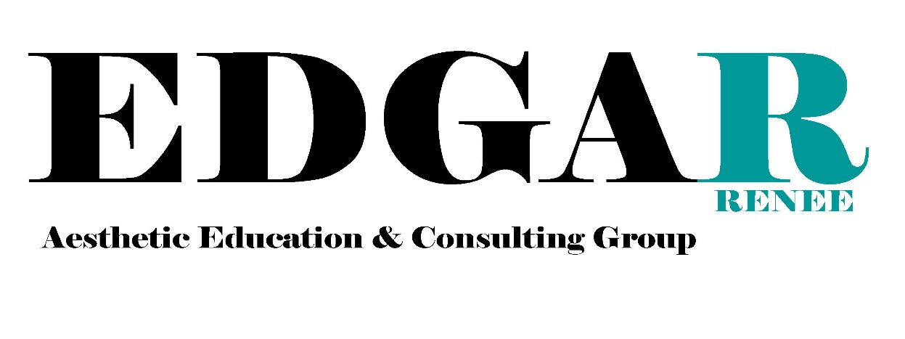
Body Vacuum Cupping Techniques
$280

Tight &Toning Body Treatment Techniques
$480

Anti-Cellulite Treatments
$480

Cosmetic Ingredient Knowledge
$380

Radio Frequency
$380

Ultrasound Cavitation
$380

Ultrasonic Spatula
$280

Microneedling
$450

www.edgarenee.com
614-4704415
edgarenee@gmail.com
IG: @edgareneegroup

