- *Aesthetic Fundamentals
5 C.E. Hours $380

- *Skin Conditions
5 C.E. Hours $380

- Understanding Galvanic Current Techniques
5 C.E. Hours $380

- *Deep Cleansing Techniques (Desincrustation)
5 C.E. Hours $380

- Deep Penetrating Techniques (Iontophoresis)
5 C.E. Hours $380

- *Understanding High Frequency Techniques
5 C.E. Hours $380

- Acne Specialist
5 C.E. Hours $450 with HF kit

- Detoxifying & Purifying Techniques for the Skin
5 C.E Hours $380

- Understanding & Treating the Fitzpatrick Scale
5 C.E. Hours $380

- Treating Hyperpigmentation
5 C.E. Hours $380

- Treating Aging Skin
5 C.E. Hours $380

- Microchanneling
5 C.E. Hours $450

- Microdermabrasion Techniques
5 C.E. Hours $380

- Advanced Chemical Peeling Methods
5 C.E. Hours $380 or $720 with QT Kit

- Dermaplaning
5 C.E. Hours $480 with kit

- Microcurrent Techniques for the Face
5 C.E Hours $380

- Hydra-Infusion Facial Techniques
5 C.E. Hours $380

Estheticians, Cosmetologists & *Barbers

- *Treating Folliculitis
5 C.E. Hours $380

- Facial Massage Techniques
5 C.E. Hours $380

- Accelerated Body Waxing
5 C.E. Hours $380

- Intimate Body Waxing
5 C.E. Hours $380 with kit

- Full Body Relaxation Massage
5 C.E. Hours $380 with kit

- Hot Stone Massage
5 C.E. Hours $450 with kit

- Hot & Cold Stone Body Treatment
5 C.E. Hours $450 with kit

- Microcurrent Gloves Massage
5 C.E. Hours $380 or $680 with kit

- Body Vacuum Cupping Techniques
5 C.E. Hours $380

- Tight &Toning Body Treatment Techniques
5 C.E. Hours $380

- Anti-Cellulite Treatments
5 C.E. Hours $480 with kit

- Cosmetic Ingredient Knowledge
5 C.E. Hours $380

- Lash Enhancement & Brow Lamination
5 C.E. Hours $450 with kit

- Spa Manicuring & Pedicuring
5 C.E. Hours $380

- Nail Enhancement Techniques
5 C.E. Hours $380

- Business Bootcamp
5 C.E. Hours $380

- Instructor CE Training
8 C.E. Hours $380

- Educator Training
5 C.E. Hours $380

- Ohio Required Sanitation
3 C.E. Hours $105

Courses
- Cosmetician
10-Class Course $5,495 with kit

- Permanent Makeup
5-Day Course $3,800 with kit

- Advanced Permanent Makeup
1-Day Course $800 with kit

- Microblading
2-Day Course $2,200 with kit

- Advanced Microblading
1-Day Course $1,000 with kit

- *Advanced Peeling Techniques
14 C.E. Hours 2-Day Course $1,200

- Eyelash Specialist
14 C.E. Hours 2-Day Course $1,200 with kit

- Holistic Aesthetic Techniques
14 Hours 2-Day Class $700

- Holistic Approaches through Aesthetics to Cancer Care Precautions
14 Hours 2-Day Class $700

We are a licensed permanent cosmetics & microblading facility. We also offer apprenticeship hours for counties that have this requirement.

All C.E. classes include the required 3 hours of required state board sanitation& 1 hour of wellness in the price. Required classes are offered monthly.

- Aesthetic Fundamentals
$380

- Skin Conditions
$380

- Ventosis Techniques for the Face
$380

- Galvanic Current Techniques
$380

- Deep Cleansing Techniques (Desincrustation)
$380

- Deep Penetrating Techniques (Iontophoresis)
$380

- Understanding High Frequency Techniques
$380

- Acne Specialist
$380 or $450 with HF kit

- Detoxifying & Purifying Lymphatic Techniques
$380

- Understanding & treating the Fitzpatrick Scale
5 C.E. Hours $380

- Resolving & Minimizing Hyperpigmentation
$380

- Aging Skin Programs and Techniques
$380

- Advanced Peeling Techniques
2-Day Course $1,200

- Diamond Tip Microdermabrasion Techniques
$380

- Advanced Chemical Peeling Methods
$320 or $720 with QT kit

Nurses

- Dermaplaning Treatment Technique
$480 with kit

- Microcurrent Techniques for the Face
$380

- Hydra-Infusion Facial Techniques
$380

- Treating Folliculitis
$380

- Microcurrent Gloves Massage
$380

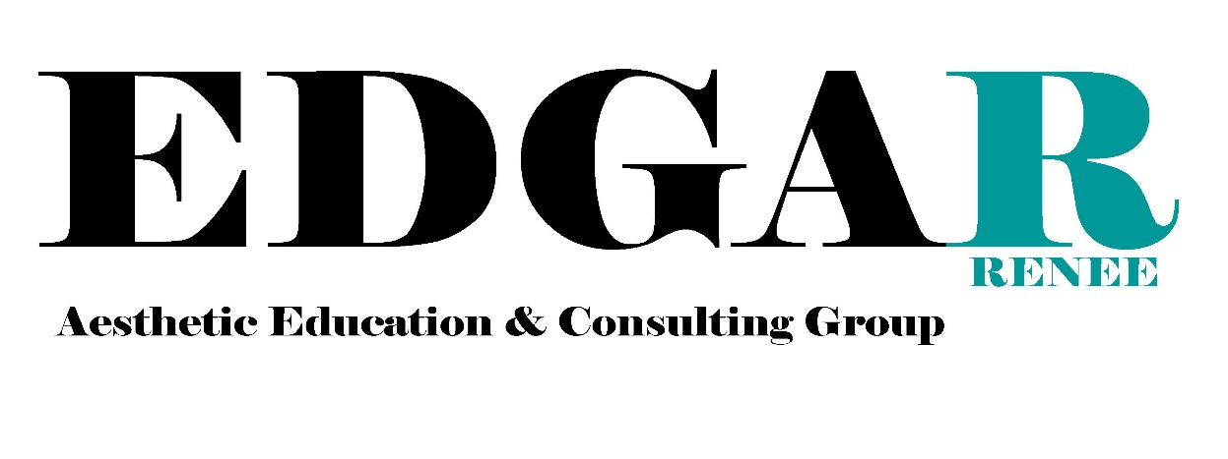
- Body Vacuum Cupping Techniques
$280

- Tight &Toning Body Treatment Techniques
$480

- Anti-Cellulite Treatments
$480

- Cosmetic Ingredient Knowledge
$380

- Radio Frequency
$380

- Ultrasound Cavitation
$380

- Ultrasonic Spatula
$280

- Microneedling
$450

www.edgarenee.com
614-470-4415
edgarenee@gmail.com
IG: @edgareneegroup

